**Weekly Report – 2nd week**

Name :- Vaibhav Bhardwaj

Class :- MCA 3rd Semester

Roll No. :- 2222888

Day 5:-

* 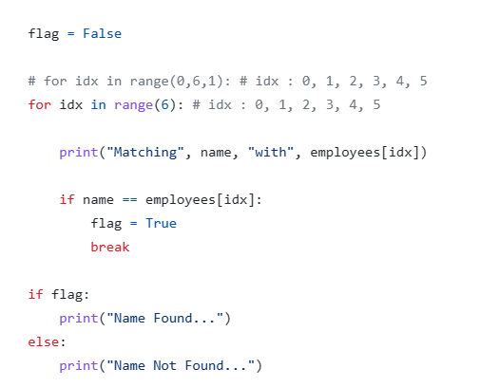Loops
* 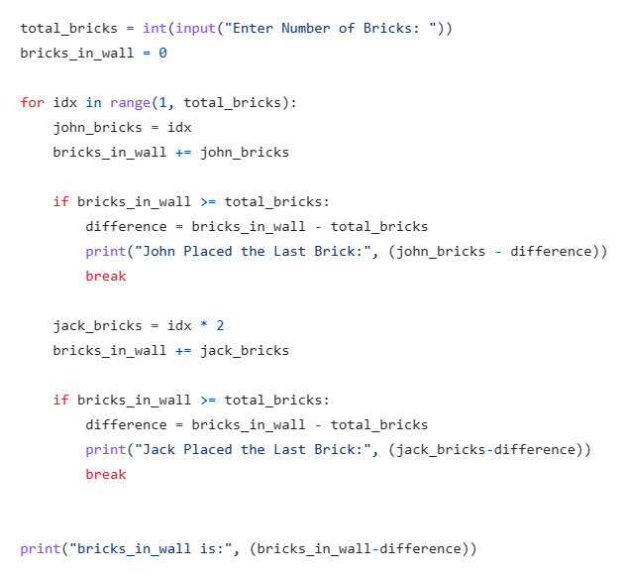Functions

Day 6:-

* 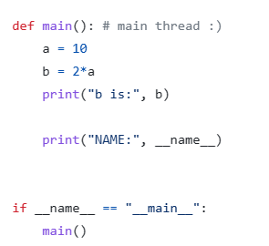main() in python
* 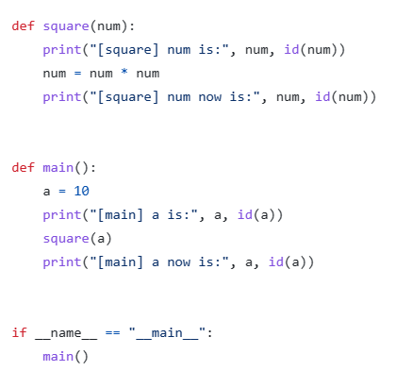Functions in Memory
* 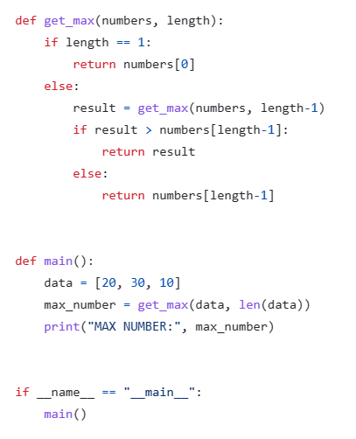Recursion

Day 7:-

* 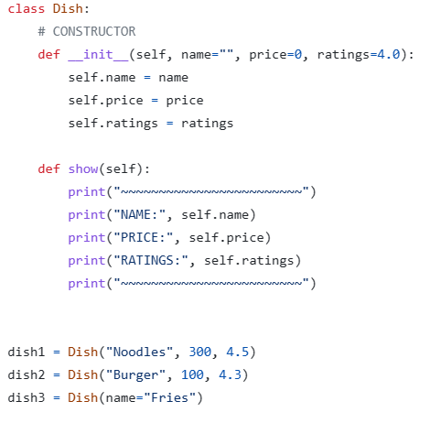OOPS
* Principle of OOPS
  1. Identify Object and what data goes inside object
  2. Write its representation in the code i.e. class
  3. From the class create a real object in memory

Day 8:-

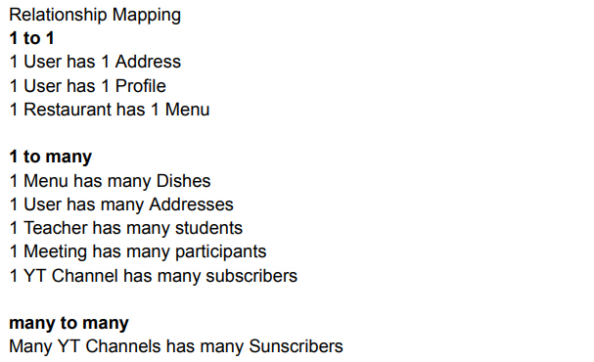

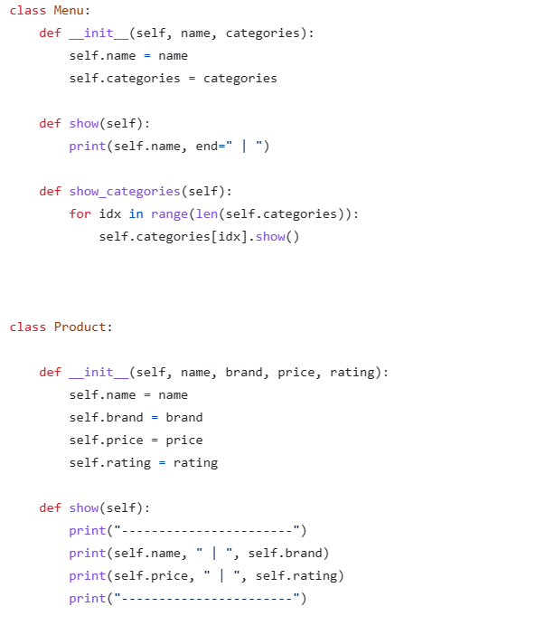

Day 9:-

* 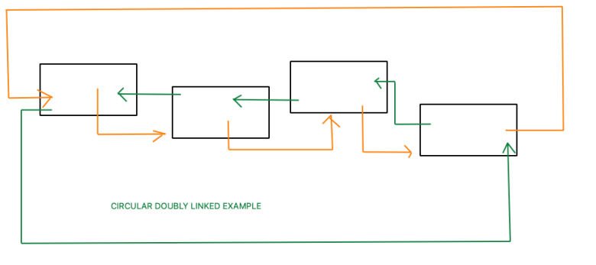Data Structures

